**Location Based Service for Red Cab Taxi**

Project Proposal

By

**Miss. Krittika Yothawuth 542115004**

**Mr. Nattawood Thobood 552115025**

Department of Software Engineering   
College of Arts, Media and Technology   
Chiang Mai University

Project Advisor

Mr. Noppon Choosri

**Document History**

|  |  |  |  |  |  |  |  |
| --- | --- | --- | --- | --- | --- | --- | --- |
| **Document Name** | **Version** | **Status** | **Date** | | **Viewable** | **Reviewer** | **Responsible** |
| **Documents** | | | | | | | |
| Location Based Service for Red Cab Taxi Proposal -V.0.1.docx | **- Add Chapter 1**   * Introduction and Background   **- Add Chapter 2**   * Business Review * Technology Review * Development Tool Review   **- Add Chapter 3**   * ISO29110   **- Add Chapter 4**   * Motivation * Aims and Objectives * Deliverables and Limits * Schedule & Milestones   **- Add Chapter 5**   * References | Draft | | June 3rd, 2015 | KY, NT, NC | KY, NT | KY, NT e |
| Location Based Service for Red Cab Taxi Proposal -V.0.2.docx | * Rewrite Chapter 1 * Fix Business Tools and Software Review * Rewrite Chapter 4 * Fix References | Draft | | June 4th, 2015 | KY, NT, NC | KY, NT | KY, NT e |
| Location Based Service for Red Cab Taxi Proposal -V.0.3.docx | * Fix Technology Review * Fix Motivation * Fix Aims and Objectives * Fix Limits * Fix References * Add Abstract | Draft | | June 5th, 2015 | KY, NT, NC | KY, NT | KY, NT e |
| Location Based Service for Red Cab Taxi Proposal -V.1.0.docx | * Fix Abstract * Fix Business Tools and Software Review * Fix Deliverables * Fix Schedule & Milestones | Reviewed | | June 8th, 2015 | KY, NT, NC | KY, NT | KY, NT e |
| Location Based Service for Red Cab Taxi Proposal -V.1.1.docx | * Fix Introduction and Background * Fix Motivation * Fix Aim * Fix Limit * Fix Schedule & Milestones | Reviewed | | June 22nd, 2015 | KY, NT, NC | KY, NT | KY, NT e |

**\*KY = Krittika Yothawuth *NT = Nattawood Thobood *NC = Noppon Choosri**

**Abstract**

Local transportation in Chiang Mai relies heavily on the ‘Red Cab Taxi’, commonly known as “Songthaew”. The process of accessing this transportation method can be quite difficult and even daunting for tourists with limited or no Thai language. It is even harder for anyone that is hearing impaired. The ability to use this transportation method always requires negotiation and communication. This Proposal will establish a new “Location Based Service for Red Cab Taxis”. This new system that we propose, will improve the services of the Red Cab taxi through the use of an Android application for both drivers and passengers. The application will help both drivers and the passengers improve the taxi service by reducing the need to directly communicate, thus reducing direction and pricing errors. This Android application will also assist in eliminating fare fraud emanating from the driver by calculating the fare before the passenger gets in a Red Cab. It will also identify each driver's information and the Taxi registration number, as well as identifying the passengers proposed travel route for the Red Cab. Finally, the application will also help to promote tourism in Chiang Mai by providing tourist information to the passenger while traveling.

Table of Contents

Chapter One | Introduction and Background 4

Chapter Two | Literature Review 6

2.1 Business Review 6

2.2 Business Tools and Software Review 9

2.2.1 Technology Review 9

2.2.2 Development Tool Review 16

Chapter Three | Quality Standard 20

3.1 ISO29110 20

Chapter Four | Project Plan 21

4.1 Motivation 21

4.2 Aims and Objectives 22

4.2.1 Aims 22

4.2.1 Objectives 22

4.3 Deliverables and Limits 22

4.3.1 Annotations 22

4.3.2 Deliverables 23

4.3.2.1 The System Architectures 23

4.3.2.2 Features 24

4.3.3 Limits 25

4.3.4 Future work 25

4.4 Software Process 26

4.5 Schedule & Milestones 27

4.5.1 Milestones 27

4.5.2 Schedule Plan 28

Chapter Five | References 32

Chapter One | Introduction and Background

Public Transportation in Chiang Mai is quite unique. The population of Chiang Mai is approaching one million in the greater metropolitan area (960,906 estimates 2008). However Chiang Mai attracted more than 14 million tourists in 2013, according to the Thailand Tourist Association. This figure is made up of 4.6 million foreign tourists and 9.5 million Thai visitors. This influx of visitors has put a strain on the city’s infrastructure including transportation. The public buses are not enough for all of the people. The old city is very much the hub of tourism and commercial activity in Chiang Mai. This area is designated by the old city walls and a waterway and receives the majority of foreign visitors. Traveling around places in Chiang Mai, locals, and other Thai people would have their own vehicle, either car or motorbike. Visitors can rent such vehicles, but most would use the public transportation, which is known as the “Songthaew” or Red Cab. The Red Cabs in Chiang Mai are minibusses carrying up to 10 people per cab. These Red Cabs run in the city and take passengers around the city, similar to any taxi. The passengers have to flag down the Red Cab and tell the driver their destination. Then they will make a deal with the price. After that, the driver will decide if he is going to carry that passenger or not. Moreover, in one cab, there can be many passengers who have different destinations. Therefore, the driver has to decide which route he is going to take and which passenger he will drop off first.

As mentioned above, Chiang Mai is a very beautiful and historical city with many wonderful attractions which draws millions of tourists every year. Foreign tourists generally do not speak Thai but need to use the Red Cab taxi service as this is one of the few methods of public transportation in the city. Often it is difficult for foreigners to communicate with the Red Cab driver about the destination and the fare. This adds to the traffic congestion in the city because making a deal about the fare holds the taxi on the road longer than necessary and blocks the traffic behind the Red Cab.

If you are hearing impaired attempting to flag down a Red Cab and negotiate a destination and fare is near impossible as your disability limits your ability to communicate with the driver.

All passengers like to know the taxi fare in advance, or if not, they like to see a meter that determines the fare based on the mileage traveled. The current Red Cab system does not offer this service and, therefore, allows unscrupulous Red Cab drivers to cheat passengers on the fare. Further, currently any Red Cab passenger does not know the identity of the driver or who in the cab will be delivered first. Moreover, in many cases they do not know whether the driver is taking them further away from their destination or sometimes the wrong way.

Therefore, our “Location Based Service for Red Cab Taxis” system will help develop the Red Cab transportation service by assisting the drivers, and the passengers communicate less. The passengers only need to use the application in choosing their destinations. After that, the system will calculate the price and generate the text into Thai so that the passengers can show it to the driver. The driver would only need to agree or refuse. Our proposed system, named above, should deliver a seamless, easy to use, electronic ‘call up’ transport application that passengers can use for the Red Cab service without needing to say a word. As a result, this will also help the hearing impaired in using the Red Cab service. If the driver agrees to pick up that passenger, the application will send the information of that destination to the driver and calculate the route to get there and show the map to both the driver and the passenger. This should help save on fuel and also the passenger would know the exact way the driver is traveling. Moreover, the driver's smartphone will send the passenger the driver's information and the cab registration number so that the passenger can contact the driver or use it when he or she has any problem with the service. While riding in the Red Cab, if there is an interesting tourist attraction near the cab, the application will send the passenger a notification and provide the information about that place. This will help promote tourist attractions in Chiang Mai.

Chapter Two | Literature Review

2.1 Business Review

2.1.1 Easy Taxi

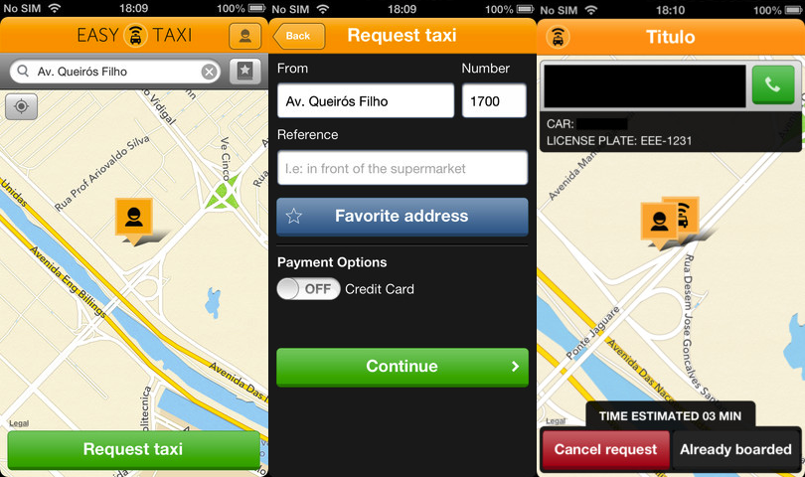

Figure 1 Easy Taxi.

Easy Taxi is the application that developed to be tools for help the passengers to connect to taxi drivers by provided the features as followed:

* Find and book a taxi along with track it in real time.
* Set a destination to calculate the fare and the arrival time and also view cab information.
* Apply discount vouchers inside the passenger’s app.
* Recent locations will be displaying on the map.

**Pros**

* Payment by Cash / Credit Card.
* Available on IOS, Android, Windows phone, blackberry, and web application.
* Passengers can provide feedback to the taxi driver.

**Cons**

* Can’t share travel information.
* The fare only becomes known at the end of the destination via meters in taxi.
* If used via a toll way passenger must pay separate bills for toll and taxi.

2.1.2 GrabTaxi

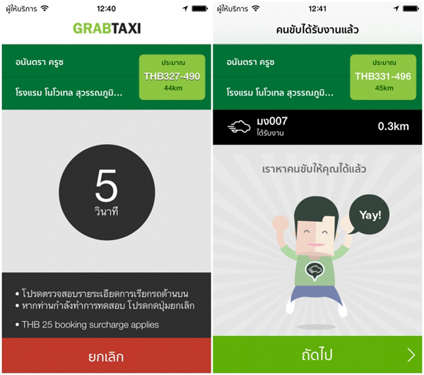

Figure 2 GrabTaxi.

GrabTaxi is a mobile E-hailing application available in 6 countries. [1] It is an automated smartphone based booking and dispatch platform for the taxi industry in South East Asia, available in Malaysia, Thailand, Singapore, Indonesia, Vietnam and Philippines.

**Pros**

* Payment by Cash / Credit Card.
* Share travel information.
* Passengers can provide feedback to the taxi driver.
* Can view the current location of the taxi

**Cons**

* The fare only becomes known at the end of the destination via meters in taxi.
* If used via a toll way passenger must pay separate bills for toll and taxi.
* In Thailand you pay 25 baht for booking (Rather than the usual five baht).

2.1.3 Uber

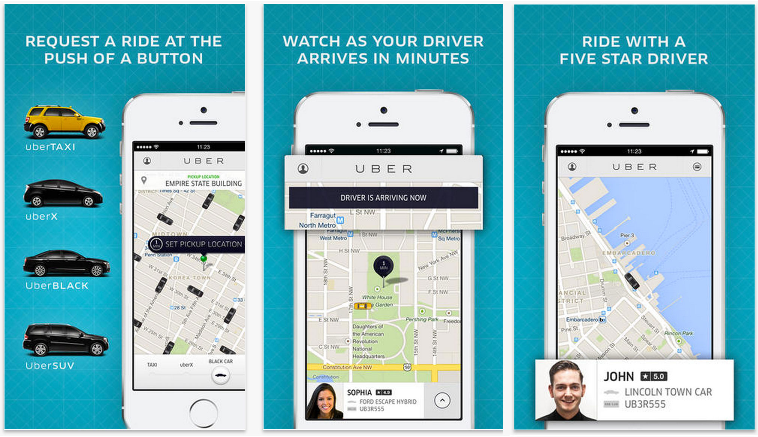

Figure 3 Uber.

“Uber” is an on-demand car service that allows you to request private drivers through applications. The service utilizes dispatch software to send the nearest driver to your location. This system is not some sort of shared ride or cab service - Uber will send you a taxi-style car. The service provides a no-cash-payment solution that charges your ride directly to the credit card on file with your account. [2]

**Pros**

* Real fare determined from the application.
* No charge ‘call-up’ service.
* Share travel information.
* Expressway in a bill.
* Don’t have to pay for traffic jams and waiting time.
* Can choose type of taxi vehicle.
* Passengers can provide feedback to the taxi driver.
* You can view current location of the taxi.

**Cons**

* Where it is legal the only payment method is with a credit card.
* Is not legal in Thailand.
* It stipulates a minimum fare.

2.2 Business Tools and Software Review

2.2.1 Technology Review

1. Google maps: location based service.

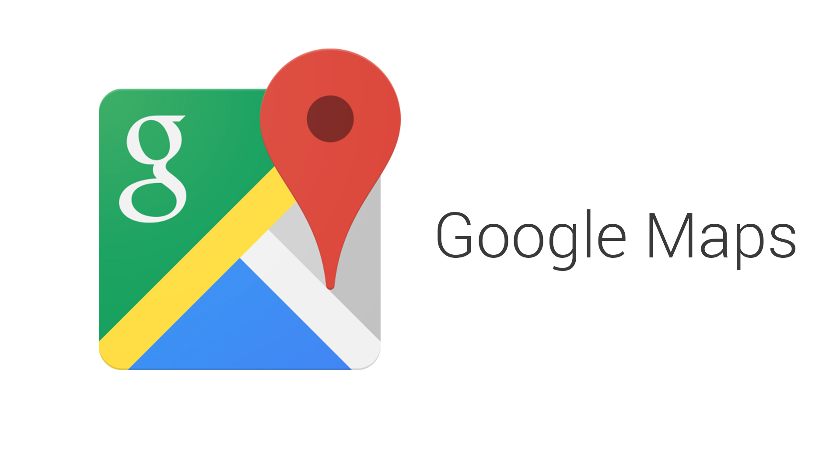

Figure 4 Google Maps Logo.

Technology Detail

This API is a free service from Google. It enables users to embed Google Maps in their web pages and provide many services for customizing and adding content to the map. [3]

Alternative Technology

* Bing Map. [4]
* HERE. [5]

The selection of this technology

* Easy to implement, just call the API Service form Google.
* Provide necessary features for control map.

1. Java: Programming language



Figure 5 Java Logo.

Technology Detail

Java is a general-purpose computer programming language that is concurrent, class-based, object-oriented, and specifically designed to have as few implementation dependencies as possible. [6]

Alternative Technology

* C++
* C#

The selection of this technology

* Security more than another programming language.
* Cross-platform capabilities.
* Work with Android Studio.

**Server**

1. MySQL: Database



Figure 6 MySQL Logo.

Technology Detail

MySQL is an open source relational database management system which used by many users around the world. It can create both standalone and server database. It can integrate with other product such as MySQL Workbench, MySQL Notifier and MySQL Connector. [7]

Alternative Technology

* SQL server. [8]
* Microsoft Access. [9]
* SQLite. [10]

The selection of this technology

* Support large project
* Open source
* Popular database server

1. Cascading Style Sheets 3 (CSS3)



Figure 7 CSS3 Logo.

Technology Detail

CSS3 is stands for Cascading Style Sheets 3. It defined how to display HTML elements that presentation of web pages, including colors, layout, and fonts. [11]

Alternative Technology

* Bootstrap.

The selection of this technology

* Easier to implement page layout.
* Standardized.

1. **HTML5**



Figure 8 HTML5 Logo.

Technology Detail

HTML5 is the fifth revision of the HTML. It is a markup language to create a webpage and present contents that can be displayed in a web browser. [12]

Alternative Technology

* HTML older version.

The selection of this technology

* Accessible sites easier than older version.
* Clean code.
* Support multimedia content.
* Standardized.

1. JavaScript



Figure 9 JavaScript Logo.

Technology Detail

JavaScript is the script language that works on prototype-based programming. Most, it used for process on the user side and also work coordinate with another component in order to increase efficiency on web development. [13]

The selection of this technology

* The language that working with HTML5
* Can use to develop the connection between server and client.

1. Node.js



Figure 10 Node.js Logo

Technology Detail

Node.js is a platform that to build scalable network in server-side real time applications. Node.js used the JavaScript as its scripting language. Also, contains server library for makes it lightweight and more efficient in server-side real time application. [14]

Alternative Technology

* Apache [15]
* Lighttpd [17]

The selection of this technology

* Appropriate for the application that have a lot of concurrent connection.
* Real time communications.
* Used lesser CPU power.
* Transfer data faster.
* Free (Open-Source).

2.2.2 Development Tool Review

1. Android Studio: Programming Tools



Figure 11 Android Studio Logo.

Development Tool Detail

Android Studio is the official integrated development environment (IDE) for Android application development, based on IntelliJ IDEA. [17]

Alternative Tool.

* Eclipse. [18]
* Visual Studio

The selection of this tool.

* Work with java for android programming.
* Easy to integrate Google Cloud Messaging and App Engine
* Free (Open-Source).

1. Wi-Fi Direct: Data transmission

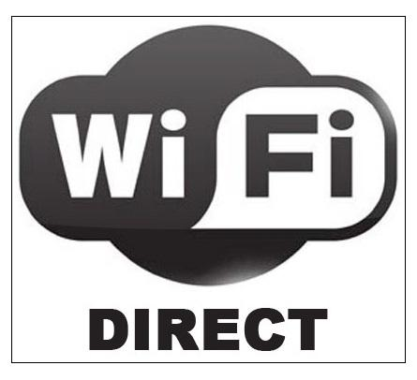

Figure 12 Wi-Fi Direct.

Technology Detail

Wi-Fi Direct is a new technology defined by the Wi-Fi Alliance aimed at enhancing direct device-to-device communications in Wi-Fi. Thus, given the wide base of devices with Wi-Fi capabilities, and the fact that it can be entirely implemented in software over traditional Wi- Fi radios, this technology is expected to have a significant impact. Wi-Fi Direct, presents an experimental evaluation that portrays the performance to be expected in real scenarios. In particular, it quantifies the delays to be expected in practice when Wi-Fi Direct devices discover each other and establish a connection. It also provides novel power saving protocols. [19]

Alternative Tool.

* Bluetooth. [20]
* Internet.

The selection of this tool.

* Fast data transmission
* Popular near transmission.

1. Global Positioning System (GPS)



Figure 13 GPS.

Technology Detail

The GPS is a space-based satellite navigation system that provides location and time information in all weather conditions, anywhere on or near the earth where there is an unobstructed line of sight to four or more GPS satellites. The system provides critical capabilities to military, civil, and commercial users around the world. [21]

The selection of this tool.

* Potential access to all general mobiles.
* Easy to find location.
* Identification of coordinates on any map.

1. IntelliJ IDEA: Server tool programming



Figure 14 IntelliJ IDEA Logo.

Technology Detail

IntelliJ IDEA is a Java integrated development environment (IDE) for developing computer software. [22]

Alternative Tool.

* Eclipse.
* Net Beans IDE
* Microsoft SQL server Management Studio

The selection of this tool.

* Supports all major languages, technologies and frameworks.
* Automatically maintains the code quality.
* Tracks and fixes errors on all levels.

Chapter Three | Quality Standard

3.1 ISO29110

ISO 29110 is the internationally recognized standards for software development of a single application. In Thailand there is also standards for the development of software. These are known as the Thai Quality Software (TQS) standards. This project will apply the ISO 29110 standards for the development of the proposed application as it is most applicable in that the ISO standard applies to the development of a single software application by a single project team with no special risk or situational factors. Further, this process focuses on small company’s and is a standard important and suitable for small company’s size and budget for the preparation and development of the application.

1. Project Management process

The purpose of the Project Management process is to establish and carry out in a systematic way the tasks of the software implementation project, which allows complying with the project’s objectives within the expected quality, time and cost framework.

Activities

* Project Planning Process
* Project Plan Execution Process
* Project Assessment and Control Process
* Project Closer Process

### **Software Implementation process**

The purpose of the Software Implementation process is the systematic performance of the analysis, design, construction, integration and tests activities for new or modified software products according to the specified requirements.

Activities

* Software Implementation Initiation Process
* Software Requirements Analysis Process
* Software Architectural Design Process
* Software Construction Process
* Software Integration and Test Process
* Software Delivery Process

Chapter Four | Project Plan

4.1 Motivation

Our motivation in designing and developing the application for ‘Location Based Service for Red Cab Taxis’ system is to help the Red Cab transportation service by making the drivers and the passengers communicate less. This will help streamline the pick-up and delivery of tourists and locals. The passengers only need to use the application in choosing their destinations. After that, the system will calculate the price and translate the text into Thai for the passengers in order to show it to the driver. The driver would only need to agree or refuse. From the system above, we can see that the passengers can use the Red Cab service without needing to say a word. As a result, this also helps hearing impaired in using the Red Cab service. If the driver agrees to pick up that passenger, the application will send the information of that destination to the driver and calculate the route there and show the map to both the driver and the passenger. The application will also provide tourist information along the route to passengers. This will help promote tourist attractions in Chiang Mai.

Nowadays, Chiang Mai is a major tourist attraction in Thailand. Chiang Mai has many tourists visiting every year and sometimes foreigners have a problem communicating with the various taxi drivers about the route and the fare. As happens now, the driver sets the fare based on the stated destination. This situation opens up potential problems between passengers and drivers and allows for unscrupulous drivers to cheat their passengers on the fare and even the journey.

Further those passengers that are hearing impaired or deaf currently find arranging Red Cab taxis almost impossible due to their disability and thus being unable to communicate with the driver.

Finally, this project wants to reimage the Red Cab by providing application features, such as being able to view the direction and receive notifications about the various tourist attractions around the city. It also designed to solve the problem about the communication between the Red Cab driver and the tourist. Moreover, this application also helps the people who are hearing impaired.

4.2 Aims and Objectives

4.2.1 Aims

The aims of this project are to:

* Streamline the Red Cab Taxi service across the city of Chiang Mai
* Improve the collection and delivery of passengers using the Red Cab Taxi service
* Eliminate miss communication between users of the Red Cab Taxi service and drivers by reducing the need for verbal communication between drivers and passengers
* Eliminate potential driver fraud by ensuring transparent disclosure of passenger fares
* Provide passengers with all necessary information about their journey including tourist attractions
* Promote tourism in Chiang Mai and to limit traffic congestion caused by users of the Red Cab Taxi service

4.2.1 Objectives

To achieve the above aim, the objectives are

* To conduct literature reviews on the related technologies i.e. Wi-Fi Direct, GPS, etc.
* To analyze and specify the project requirements and tools selection.
* To implement software for the drivers and the passengers device.
* To conduct software testing in order to verify and validate code.
* To inspect all software processes and document base on varies SQA standard.
* To complete final version of the software product.
* To compile the software project report include with software document.

4.3 Deliverables and Limits

4.3.1 Annotations

GPS = Global Positioning System.

4.3.2 Deliverables

4.3.2.1 The System Architectures

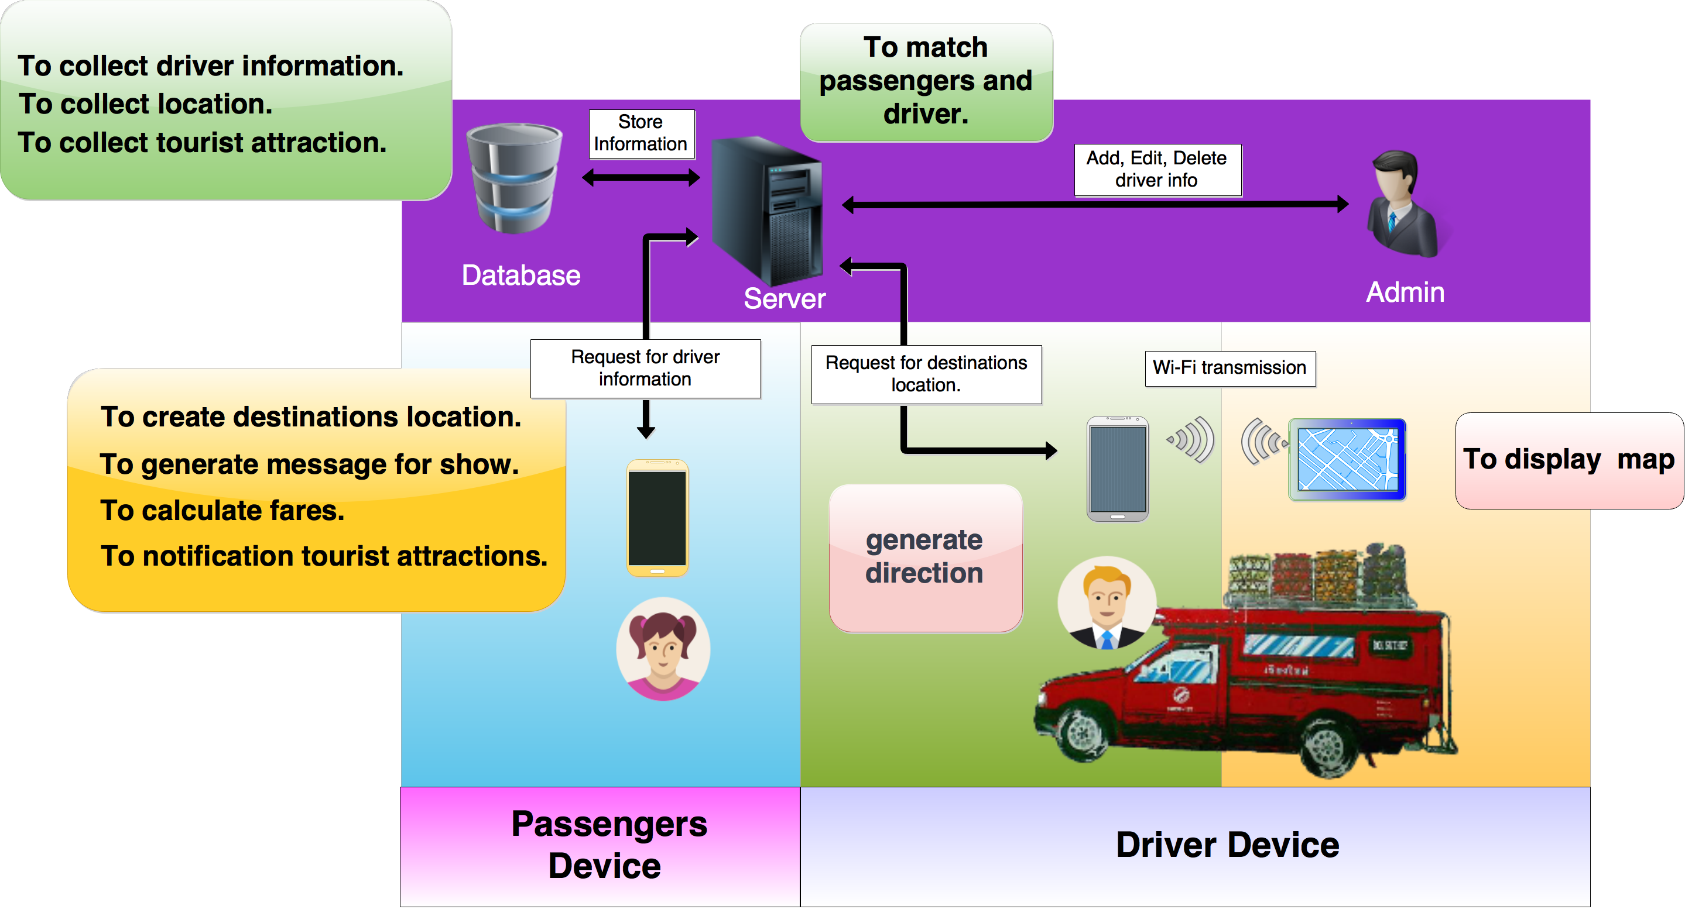

Figure 15 system architectures.

The system architectures model of “Location Based Service for Red Cab Taxi”, shown in the figure above, consists of four parts.

The first part is a mobile application for the passenger, which will be used to help the passenger to communicate with the driver and display information relevant for traveling.

The second part is a mobile application for the driver, which is used to help the driver to generate directions for all passengers in the Red Cab.

The third part is a mobile application for a tablet computer for the driver, which displays a directional map.

The fourth part is the server-side that helps to connect between the passenger and the driver and collects all information in the system.

4.3.2.2 Features

**Feature#01:** Authentication system.  
**Description**: This feature supports access to the system for user. It also includes log-out function.   
**Users:** Driver and Administrator  
**Details:**1-1: The users can login to the system.  
1-2: The users can log-out from the system.

**Feature#02** Red cab driver management system.  
**Description**: This feature supports managing red cab driver for admin. It helps administrator to add, edit, and delete information of driver in the system.   
**Users:** Administrator  
**Details:**   
1-1: The administrator can add the user (driver) to the system.  
1-2: The administrator can update the driver’s information in the system.  
1-3: The administrator can delete the user (driver) from the system.

**Feature#03** Connecting system  
**Description**: This feature supports connecting between the passenger and the driver.  
**Users:** Passenger and Driver  
**Details:**   
1-1: The passenger can find the driver via the mobile application.  
1-2: The passenger can connect to the driver.  
1-3: The driver can find the passenger via the mobile application.   
1-4: The driver can connect to the passenger.  
1-5: The system can make the connection between the passenger and the driver.

**Feature#04** Notification system.  
**Description**: This feature supports for notification for the passenger user. It helps push notification to the passenger when pass the more important places in route.   
**Users:** Passenger User  
**Details:**1-1: The passenger can get notification about the tourist attraction from the system.

**Feature#05** Travelling service system.  
**Description**: This feature support the service in the system, such as view direction, view transportation fare, and generate the Thai message for contact the driver.  
**Users:** Passenger and Driver   
**Details:**   
1-1: The passenger can make the destination.  
1-2: The passenger can view the direction from their location to the destination.  
1-3: The passenger can view the transportation fare.  
1-4: The passenger can generate the Thai message for contact the driver.  
1-5: The passenger can view the real-time direction from their location to the destination via the tablet application.   
1-6: The driver can view the direction to the destination.

4.3.3 Limits

* + The application is only available on Android operating systems.
  + Required Internet connection to use the application.
  + Available only English version.
  + Required turn on Location Services
  + The driver’s device available to use Wi-Fi Direct.
  + Red Cab that uses this system can pick up only passengers that use application.
  + The application does not support in chartering the Red Cab taxi.

4.3.4 Future work

This application can be expanded or improved in the future to fulfill the user’s requirements such as:

* Supporting more languages.
* Supporting more devices. (IOS and Windows Phone).
* Provide the traffic checking function to help the driver select the most convenient route.
* Provide the time estimating function for the passenger.

4.4 Software Process

Iterative development model

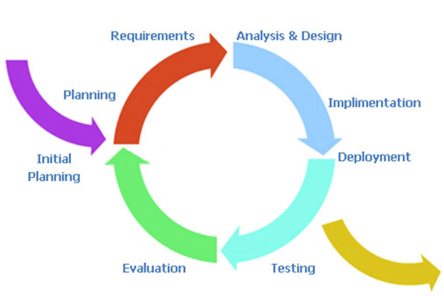

Figure 16 Iterative Development Model

Iterative development model is one of the software development models which evolved from the ‘waterfall model’. By changing process flow from step to step into iterative step. When the process flows into iterative, the process will start from the first step then go to the next step till the last. After that, the process will return to the first step and start again. The iteration will be repeat until all processes planned are completed.

**Proposal phase:** This phase is about creating a proposal for Location Based Service for Red Cab Taxi.

**Document plan phase:** This phase is about document for planning and designing the overall system from requirements given by the user. Iterative all features: This phase is about separate system into many features and then iterative create all feature from the first feature till the final feature. For this phase, it will be divided into 4 phases. There are as set out below:

* **Plan:** Planning the method for creating and test each feature.
* **Implement:** Implementing and coding each feature.
* **Test:** Testing and fixing each feature.
* **Review:** Reviewing and maintaining each feature to meet the feature plan.

**System test phase:** This phase will integrate all features into one system and then create test document from system testing.

4.5 Schedule & Milestones

4.5.1 Milestones

**Proposal Progress:**Proposal.

**Progress I:  
Feature#1:** Authentication system.  
**Feature#2:** Red cabdriver management system.

**Progress II:  
Feature#3:** Connecting system.  
**Feature#4:** Notification system.

**Progress III:**  
**Feature#5:** Travelling service system.

4.5.2 Schedule Plan

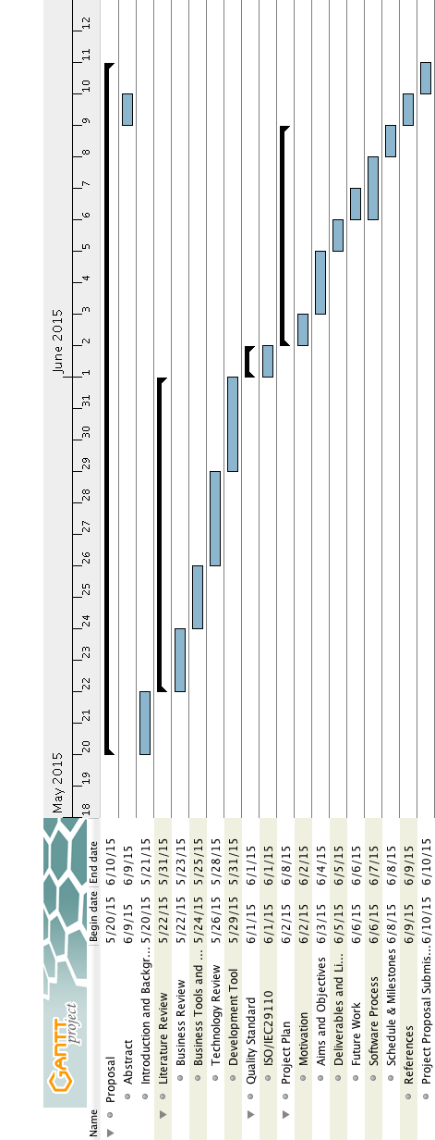

Figure 17 Project Proposal Milestone

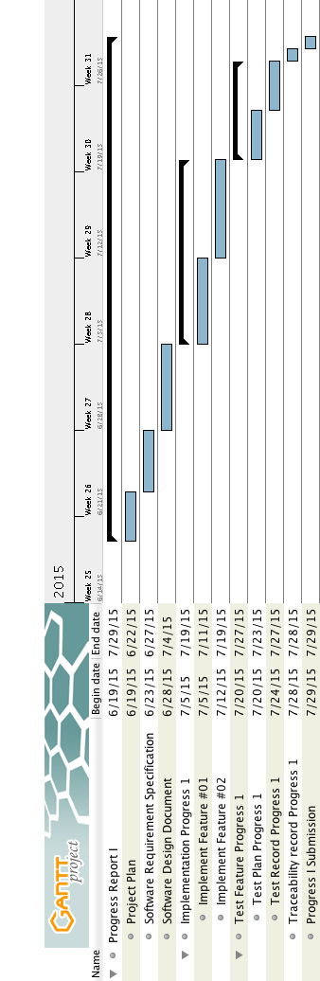

Figure 18 Progress Report I Milestone

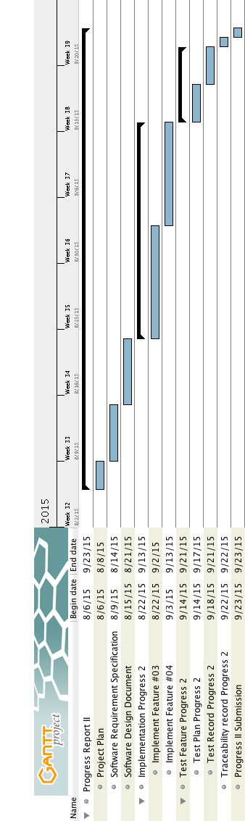

Figure 19 Progress Report II Milestone

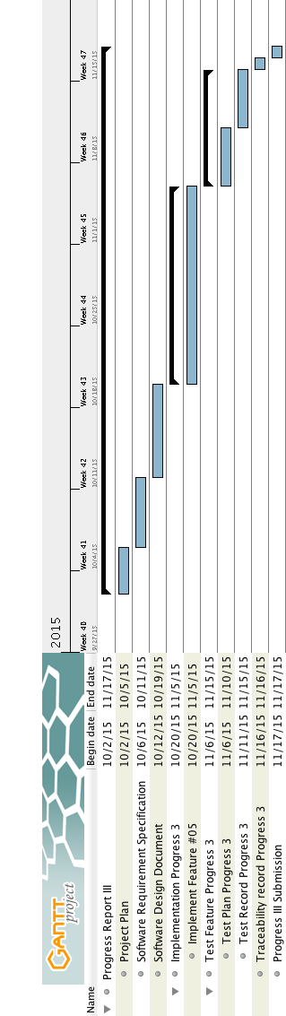

Figure 20 Final Progress Milestone

Chapter Five | References

[1] GrabTaxi. [Online] http://en.wikipedia.org/wiki/GrabTaxi (Accessed on 3 June 2015).

[2] Uber. [Online] http://www.wikihow.com/Use-Uber (Accessed on 3 June 2015).

[3] Google Map. [Online] http://maps.google.com/help/maps/getmaps/advanced- options.html (Accessed on 21 May 2015).

[4] Bing Map. [Online] http://en.wikipedia.org/wiki/Bing_Maps (Accessed on 21 May 2015).

[5] HERE [Online] https://company.here.com/here/ (Accessed on 5 June 2015).

[6] Java. [Online] http://en.wikipedia.org/wiki/Java_(programming_language) (Accessed on 21 May 2015).

[7] MySQL [Online] http://en.wikipedia.org/wiki/MySQL(Accessed on 8 June 2015).

[8] SQL Server [Online] http://www.serverintellect.com/servers/sql-server/ (Accessed on 8 June 2015).

[9] Microsoft Access. [Online] http://en.wikipedia.org/wiki/Microsoft_Access (Accessed on 8 June 2015).

[10] SQLite [Online] https://www.sqlite.org (Accessed on 5 June 2015).

[11] CSS3. [Online] https://developer.mozilla.org/en-US/docs/Web/CSS/CSS3 (Accessed on 21 May 2015).

[12] HTML5. [Online] http://www.html5rocks.com/ (Accessed on 21 May 2015).

[13] JavaScript [Online] <http://en.wikipedia.org/wiki/JavaScript> (Accessed on 21 May 2015).

[14] Node.js. [Online] http://nodejs.org/, https://github.com/joyent/node (Accessed on 21 May 2015).

[15] Apache. [Online] http://httpd.apache.org (Accessed on 21 May 2015).

[16] Lighttpd. [Online] http://en.wikipedia.org/wiki/Lighttpd (Accessed on 21 May 2015).

[17] Android Studio. [Online] http://developer.android.com/tools/studio/index.html (Accessed on 21 May 2015).

[18] Eclipse. [Online] http://en.wikipedia.org/wiki/Eclipse_(software) (Accessed on 21 May 2015).

[19] Wi-Fi Direct [Online] http://www.campsmur.cat/files/camps_ssavedra_serrano_WCM_11_00112_final_version.pdf (Accessed on 5 June 2015).

[20] Bluetooth [Online] http://en.wikipedia.org/wiki/Bluetooth (Accessed on 5 June 2015).

[21] GPS [Online] http://en.wikipedia.org/wiki/Global_Positioning_System (Accessed on 3 June 2015).

[22] IntelliJ IDEA. [Online] http://en.wikipedia.org/wiki/IntelliJ_IDEA (Accessed on 29 May 2015).